7.Style a web page using advanced CSS:BOX model ,background images, borders ,margins,and padding

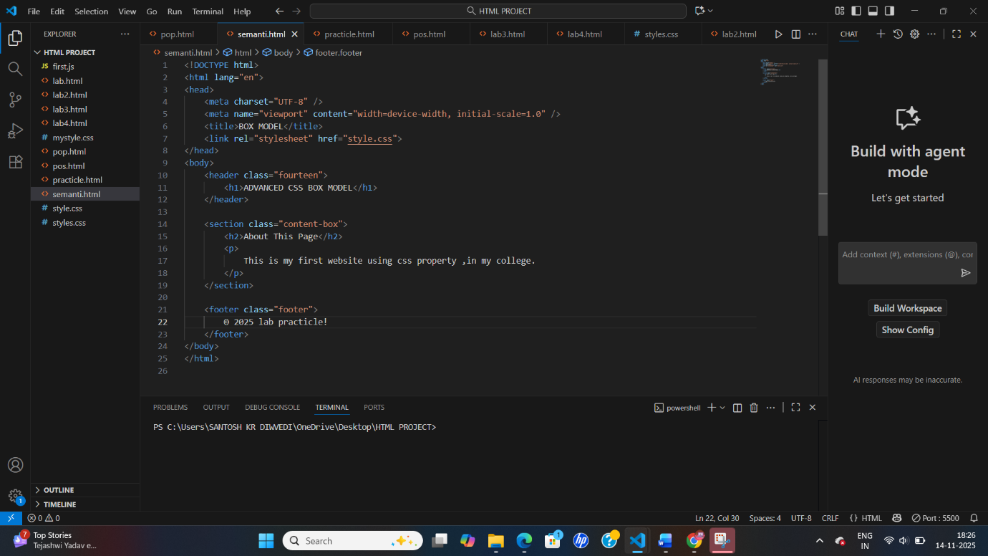
Output-